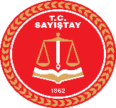
Turkish Court of Accounts

Activity: Workshop on Information Technology – IT support in auditing processes and auditing softwares

Date: 14-15 November 2018

Place: Tirana, ALBANIA

Participant Countries: TURKEY, ALBANIA, MACEDONIA, SERBIA, BOSNIA AND HERZEGOVINA, MONTENEGRO.

Participant(s): Mustafa ERSÖZ (Senior Auditor) and Nihan POLAT (Auditor)

Summary: The workshop consisted of presentations, discussions and experience sharing. ECA and all participants (except Bosnia and Herzegovina and Montenegro) make presentations about the use of IT in auditing processes and give information about the audit softwares being used for data analysis and data mining. Good practice examples are shared and opened a path for improvisation of the currently used tools and techniques.

Photo(s):

